**Results and Discussions**

**Data points (transfer learning)**

We trained the whole model on the old data and then tested it on the 2015 data we got a root mean square error of 9.39, this was more than the threshold value of 3.5, hence we retrained the model using the principle of transfer learning. For the subsequent years we got the following results:

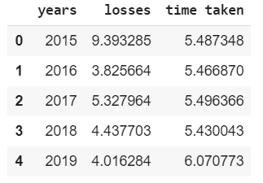

**Data points (complete retraining)**

We trained the whole model on the old data and then tested it on the 2015 data we got a root mean square error of 9.69, this was more than the threshold value of 3.5, hence we retrained the model using the principle of transfer learning.

We got the following results for the subsequent years:

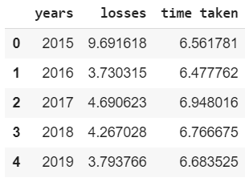

**Comparison charts**

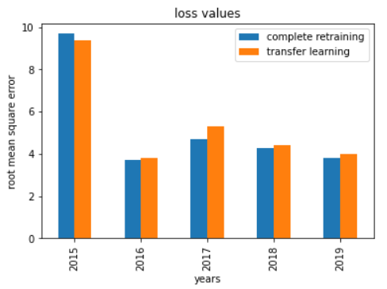

Fig1. Loss value (transfer learning and complete retraining)

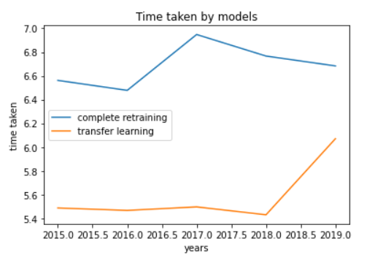

Fig 2. Time taken by models (in seconds)

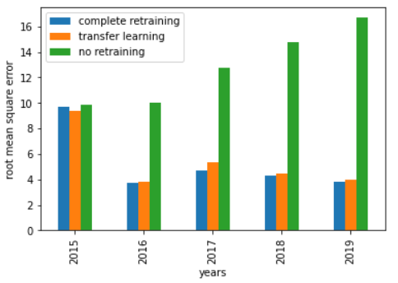

Fig 3. Comparisons of loss values

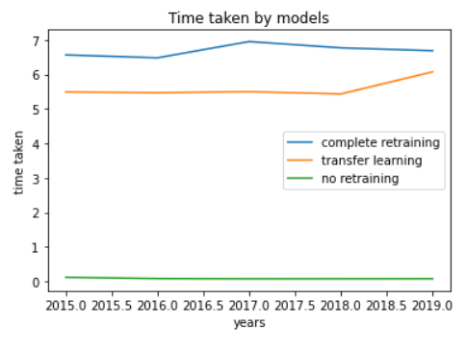

Fig 4. Comparison of time taken by the models in seconds

**Observations**

In our observation we can see that the loss value for 2015 for both transfer learning and complete retraining were much higher than the other years. We can assume from this that there was a jump in musical tastes in 2015. For the later years we get the RMS values which are all more consistent.

When we compare transfer learning to complete retraining we get better results with complete retraining, but only slightly. This is because we are retraining all the layers and hence we get better results. But one advantage of transfer learning is that it has saved all the weights of the initial training in it’s first few layers, hence it is more robust against fluctuations of data in the future.

Another advantage of using transfer learning compared to complete retraining is that it saves a lot of time, as the datapoints above show. This is because 3 layers don’t get retrained.

When we don’t retrain the model at all and use only the model that was trained on the 2008-2014 data, we can see very large loss values for all the data. Thus showing that model retraining is required to maintain performance in the long term.